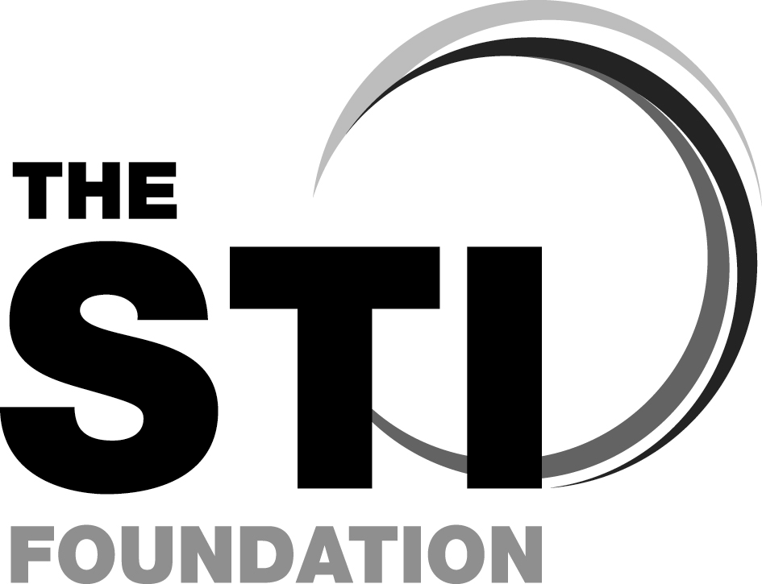

Sexually Transmitted Infections Foundation Course

STIF CORE

STIF PLUS

Courses from the British Association for Sexual Health and HIV (BASHH)

STIF CORE:

Monday 4th June 2018

STIF PLUS: Tuesday 5th June 2018

at

Marriott Hotel,

Southampton Road, Portsmouth, PO6 4SH

COURSE DIRECTOR: Dr Neelam Radja

COURSE ORGANISER:
Tristan Norris SHPNetworks.directory@solent.nhs.uk

(on behalf of BASHH)

The aim of the course is to equip participants with the basic knowledge, skills and attitudes for the effective management of sexually transmitted infections (STIs) outside the GUM setting.
Early registration is preferable. It is recommended to attend both days although if you have attended a STIF course in the past 3 years, you can attend the STIF PLUS day to update your knowledge and skills.
It is highly recommended that delegates study the appropriate modules in e-Learning for Health before attending.
This will entail around 8-12 hours of study depending on your experience. Further information about the modules will be provided by the course organisers approximately four weeks before the course commences.

The outline programme is attached.

For further information please visit http://www.stif.org.uk

This is a multi-disciplinary course and applications are invited from:
Doctors and nurses working in general practice, family planning and reproductive health, GUM, health advisers, secondary care clinicians who may encounter patients with STIs (e.g. O&G, A&E, rheumatology, ophthalmology), pharmacists, and school nurses.

Course fee (includes Coffee, Lunch & Tea)
STIF CORE £150
STIF-PLUS £150
BOTH DAYS £250

ALL APPLICATIONS SHOULD BE
RETURNED BY 31st March 2018

Details of the e-learning modules and a course manual will be sent to you nearer the time

FFPRHC Approved

Sexually Transmitted Infections Foundation Course
Monday 4th June 2018 and Tuesday 5th June 2018
Marriott Hotel, Southampton Road, Portsmouth, PO6 4SH
Name ___________________________________________
Job Title __________________________________________
NHS Trust/ Institution _____________________________________
Mailing Address for your course manual:
______________________________________________
_______________________________________________
____________________________Post Code:___________
Invoice Address:
______________________________________________
______________________________________________
____________________________Post Code:___________
Daytime Telephone contact: ________________________________
E-mail ________________________________________________

Please indicate the days which you wish to attend:
◻ DAY ONE (STIF CORE)
◻ DAY TWO (STIF PLUS – assumes attendance on a STIF Course in last 3 years)
◻ BOTH DAYS
Any Special Needs? (Please specify) _______________________

Please return completed application to Tristan Norris

E-mail: SHPNetworks.directory@solent.nhs.uk

Aim of STIF FOUNDATION course
To equip participants with the basic knowledge, skills and attitudes for the effective management of STIs. By the end of the course you should be able to:

Knowledge
- Describe the principles of STI service provision
- Recognise the issues relating to confidentiality, partner notification and treatment
- Demonstrate basic knowledge of the epidemiology and the factors involved in the transmission of STIs and how to prevent transmission
- Demonstrate basic knowledge of STIs, their presentation, diagnosis and management
- Indicate where and when to refer patients

Skills
- Demonstrate competency, and feel comfortable, in taking a sexual history
- Demonstrate the skills necessary to inform patients about reducing their risk of sexual infections and risk of unplanned pregnancy
- Optimise care pathways for patients through improved links with local services (GUM, Sexual Health, Contraceptive services, Psychosexual services, Microbiology, TOP services and Primary Care)

Attitudes
- Demonstrate an appreciation of the lifestyle and circumstances of others and how this may reflect in their presentation and impact on their management.
- Recognise the range of human sexuality, lifestyles and culture and the impact this has on transmission/ prevention counselling
- Demonstrate an understanding of how one’s personal beliefs could affect the consultation

Day 1 (STIF CORE ): Monday 4th June 2018
Programme timings may change

08.30 Registration and coffee

09:00 Welcome and Introduction- Dr Neelam Radja

09:10 Why are we here and what do we do? - Dr Sally Kidsley

09.40 Sexual history taking and practice- Barbara Patel

10.40 Coffee/Tea Break

10.55 Swabs and Tests- Emma Wells

11.25 Partner Notification- Toby Lamb

12.10 HIV Testing - Dr Reena Mani

12.55 Lunch

13.45 Small Group Workshop 1 and 2

14.30 Small Group Workshop 1 and 2

15.15 Coffee/Tea Break

15.30 Small Group Workshop 3 and 4

16.15 Small Group Workshop 3 and 4

17.00 Close and Evaluation

Small Group Workshops 1-4:
- Genital sores- Dr Seema Malik
- Sexual Health Promotion, Risk Reduction, Prevention- Dan Clerkin and Sarah Cavill
- Vaginal discharge- Joanna Rees TBC
- Young People and Sexual Health- Michelle Wilson

Day 2 (STIF PLUS): Tuesday 5th June 2018
Programme timings may change

08.30 Coffee and registration

09:00 HIV in Primary Care- Dr Leela Sanmani

10.00 Small Group Workshop 5 and 6

10.45 Coffee/Tea Break

11.00 Small Group Workshop 5 and 6

11.45 Sexual Assault and Domestic Violence – Dr Ellie Birtley

12.30 Lunch

13.15 Small Group Workshop 7 and 8

14.00 Small Group Workshop 7 and 8

14.45 Coffee/Tea Break

15.00 Syphilis- Dr Sam Samraj

15.30 Viral Hepatitis- Dr Corinne Brooks

16.15 STIs in Pregnancy- Dr Alison Blume

17.00 Close and Evaluation

Small Group Workshops 5-8:
- Female Pelvic Pain – Dr Najia Aziz
- Conditions affecting genital skin- Dr Cordelia Chapman
- Male Dysuria, Testicular Pain and Testicular Lumps- Dr Sangeetha Sundaram
- Gay, bisexual and other MSM- Kevin Turner

