

Newsletter
29th May 2024

This newsletter - sent on Mondays, Wednesdays and Fridays - contains important information and resources to support community pharmacies across England.

In this update: Register for our Pharmacy Owner regional events; Health Committee's report on pharmacy; Pharmacy First claims and payment schedules; Pharmacist Support seeks new trustees.

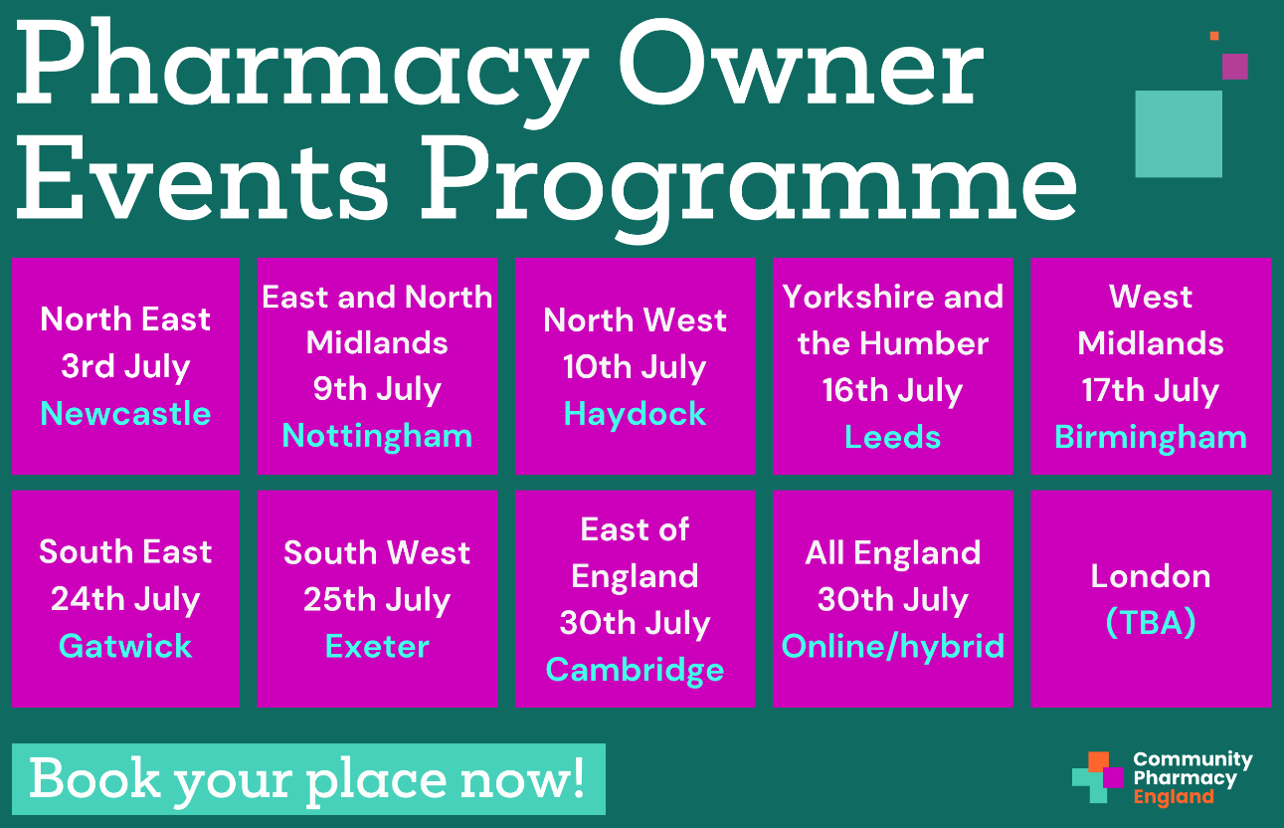

We are holding a series of regional roadshow events across the country as part of our commitment to continue engaging with pharmacy owners and LPCs. Taking place through July, the events will see our Chief Executive Janet Morrison and the team, as well as Committee Members, visiting every NHS England region to hear directly from pharmacy owners and LPCs.
These events will allow you to share your views, ask us questions and learn about the work Community Pharmacy England is doing to try to ease the critical pressures you are facing. The events will also cover topics such as ongoing pressures in community pharmacy, the Community Pharmacy Contractual Framework (CPCF) for 2024/25, the future vision and strategy for the sector, and the role of community pharmacy in the wider political and NHS landscape.
We encourage pharmacy owners to register for these free events in advance, as spaces are limited. For those unable to attend face-to-face, a hybrid session will be held later in the summer, and further engagement opportunities will be available throughout the year.

Read more and book your place

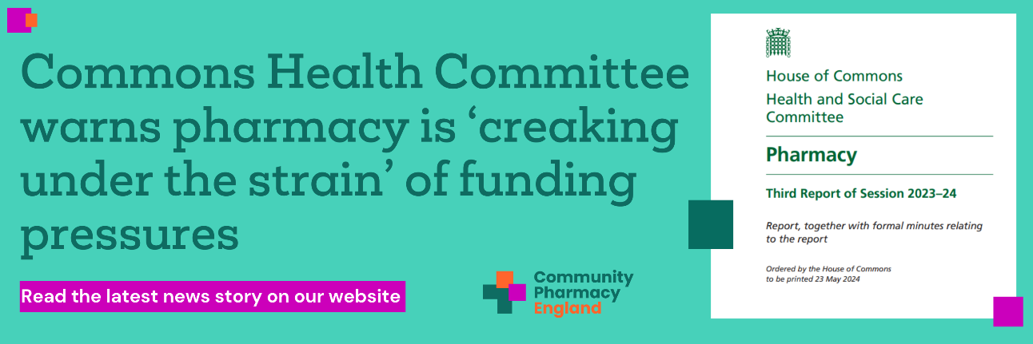

In a report published today, the Health Committee has noted that community pharmacies are ‘creaking under the strain of funding pressures’, and the MPs criticised the ‘insufficient’ policies on medicine supply issues. The report noted that ‘There is clearly something wrong if the funding that pharmacies receive from the NHS does not cover medicine costs, given their core function of dispensing medicines.’
In February, Our CEO, Janet Morrison, and Director of Pharmacy Funding, Mike Dent, gave evidence to the inquiry and emphasised the importance of easing supply problems and addressing the financial challenges faced by pharmacies.
Community Pharmacy England welcomes the report and plans to discuss the recommendations with the new government after the General Election, focusing on transparent and fair funding, reviewing the medicine supply chain, and investing in the future of community pharmacies.

Read more, including our response

Claiming and payment schedule for Pharmacy First
Pharmacy owners have a deadline to claim payments for the Pharmacy First service. Claims for payments should be submitted within one month of, and no later than three months from the claim period for the chargeable activity provided. For example, if you have not yet submitted your claim for your February 2024 consultations, you must do so by 5th June 2024 to be entitled to payment.
We have provided a table containing the date on which pharmacy owners will receive their £1,000 monthly fixed payment (if the pharmacy has reached the minimum threshold of clinical pathway consultations for that month) as well as their consultation fees and reimbursement of medicines/appliances supplied.
There are also some frequently asked questions (FAQs) regarding the payment process and how to reconcile the submitted claims with the information received by NHSBSA.
Learn more and read the FAQs

Pharmacist Support seeks passionate pharmacists as Trustees
Pharmacist Support, the pharmacy profession's independent charity, is looking for two new pharmacist trustees to join their board.
The charity provides support and services to pharmacists and their families, former pharmacists, pharmacy students, and trainee pharmacists. Interested candidates can apply by submitting their CV and cover letter by 12 noon on 7th June 2024. Interviews will be held in Manchester on 8th July 2024.

Learn more



Community Pharmacy England
Address: 14 Hosier Lane, London EC1A 9LQ
Tel: 0203 1220 810 | Email: comms.team@cpe.org.uk
Copyright © 2024 Community Pharmacy England, All rights reserved.
You are receiving this email because you are subscribed to our newsletters. Please note Community Pharmacy England is the operating name of the Pharmaceutical Services Negotiating Committee (PSNC).

