

Newsletter
24th May 2024

This newsletter - sent on Mondays, Wednesdays and Fridays - contains important information and resources to support community pharmacies across England.

In this update: General Election campaigning begins; HCFS and engaging with GPs; Medicine Supply updates, including Creon SSPs.

General Election campaigning begins
The Prime Minister has announced the date for the next UK General Election as 4th July 2024, and Community Pharmacy England is continuing the critical work to build supporters in readiness for the new Parliament.
An election had been expected this year and we have long been gearing up for this. Our influencing and lobbying work in recent months has included briefing numerous politicians and the health policy teams from all parties, raising awareness of core pharmacy issues in the media, and setting out clear asks for the future, including in the joint #VotePharmacy Manifesto.
An election campaigning period is a good time to reach out to political parties and prospective candidates to get them thinking about community pharmacies. We have begun contacting a wide list of Prospective Parliamentary Candidates, working with LPCs to arrange pharmacy visits, and are ready to brief new MPs when they take office.
Community pharmacy owners and their team members are encouraged to help amplify our national work by contacting their local election candidates. We are updating our resources and guidance to assist with these efforts.

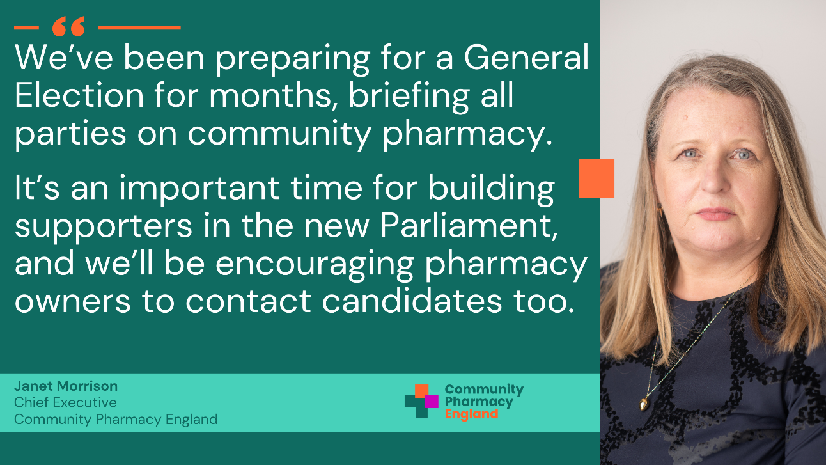

Read more



Community Pharmacy England has published the third of a series of articles to help pharmacy owners and their teams maximise the potential of the Hypertension Case-finding Service (HCFS).

This article emphasises the importance of engaging with local general practices (GPs) and primary care networks to ensure they are aware that patients can be referred to pharmacies for blood pressure checks. Additionally, the article highlights beneficial resources and showcases examples of collaborative working between general practices and community pharmacies.

Learn more and access the resources

Medicine Supply updates
New Serious Shortage Protocols issued
The Department of Health and Social Care (DHSC) has issued Serious Supply Protocols (SSPs) today for the following medication: (click the hyperlinks below for more information)
- Creon® 10000 gastro-resistant capsules
- Creon® 25000 gastro-resistant capsules

Further supply notices
DHSC has also issued a national patient safety alert and medicine supply notifications for the following items (click the hyperlinks below for more information):
- National Patient Safety Alert: Shortage of Pancreatic enzyme replacement therapy (PERT)
- Nortriptyline 10mg/5ml and 25mg/5ml oral solution sugar-free
- Clarithromycin 125mg/5ml and 250mg/5ml oral suspensions
- Salbutamol 2.5mg/2.5ml and 5mg/2.5ml nebuliser liquid unit dose vials

If you would like to help raise awareness of the worsening medicines supply situation, we have a range of new resources available to support this.
View our medicines supply resources



Community Pharmacy England
Address: 14 Hosier Lane, London EC1A 9LQ
Tel: 0203 1220 810 | Email: comms.team@cpe.org.uk
Copyright © 2024 Community Pharmacy England, All rights reserved.
You are receiving this email because you are subscribed to our newsletters. Please note Community Pharmacy England is the operating name of the Pharmaceutical Services Negotiating Committee (PSNC).

