

Newsletter
22nd May 2024

This newsletter - sent on Mondays, Wednesdays and Fridays - contains important information and resources to support community pharmacies across England.

In this update: Community Pharmacy England briefs Peers on 2024 Pharmacy Pressures; Pharmacy First GP resources; Clarithromycin SSPs reactivated; Price adjustment for Azathioprine oral suspension.

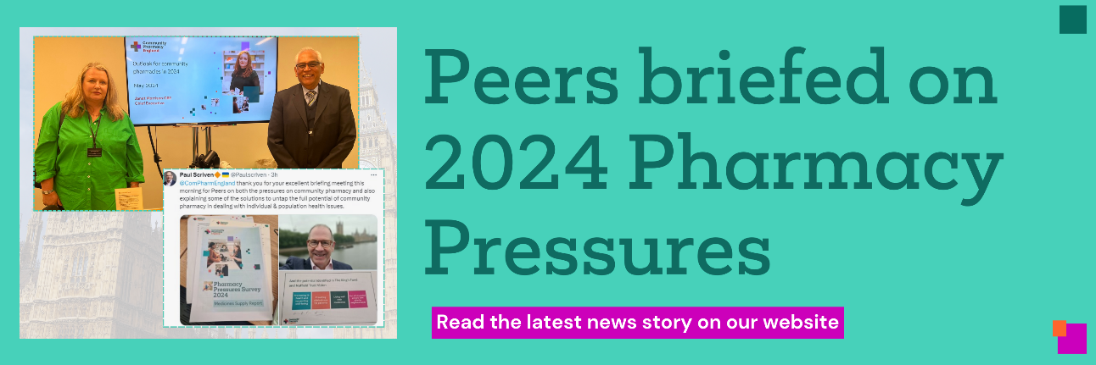

Community Pharmacy England briefed Peers on the severe challenges facing community pharmacies, including the findings of the 2024 Pressures Survey. In a wide-ranging discussion, Peers were taken through findings on medicine supply issues, funding pressures, and pharmacy workforce shortages, as well as hearing about Pharmacy First.
Chaired by former Pharmacy Minister Lord Hunt of Kings Heath, Peers heard from community pharmacist and Committee Member Prakash Patel and our Chief Executive, Janet Morrison, on the intolerable pressures facing the sector in 2024.
Janet presented to Peers on the main findings of the survey following the publication of our first report on medicine supply issues and discussed the critical need for increased funding for community pharmacies. Attendees expressed concern about pharmacists dispensing medication at a loss, but were also keen to discuss potential of pharmacy and hear about our vision for the future, subject to adequate funding and support.

Continue reading

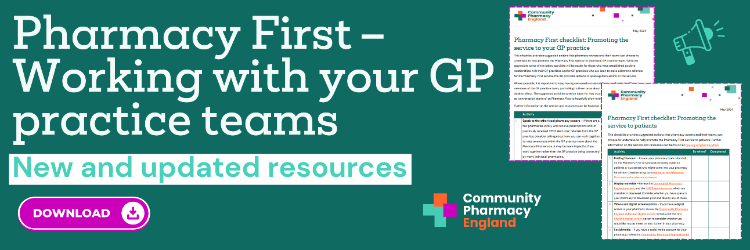

The success of the Pharmacy First service relies on strong relationships between community pharmacies and local general practices. These relationships will encourage general practice teams to refer patients to Pharmacy First and other community pharmacy services when appropriate.

We all know achieving long-term changes in practice can take time and, to support pharmacy owners, their teams and LPCs to keep engaging with local general practice colleagues, we have published some new resources and updated existing resources.

Read more and download the resources

Two Clarithromycin SSPs reactivated
In response to a significant ongoing disruption to the supply of Clarithromycin 125mg/5ml and 250mg/5ml oral suspension, Ministers have authorised the Department of Health and Social Care (DHSC) to reactivate two Serious Shortage Protocols (SSPs).
Effective from today until 21st June 2024, the reactivated Clarithromycin SSPs (SSP053 and SSP054) provide pharmacists with procedures to follow in providing suitable alternative products to help reduce the number of patients having to return to their prescriber for a replacement prescription.
Find out more

Price adjustment for Azathioprine 50mg/5ml oral suspension (February and March 2024)
Following representations made by Community Pharmacy England, DHSC has agreed to reimburse pharmacies for prescriptions of Azathioprine 50mg/5ml oral suspension (Special Order) submitted as dispensed in February and March 2024.
The reimbursement will be based on the product endorsed on the prescription. This decision was made in response to concerns raised by pharmacy owners regarding the reimbursement risks of supplying the licensed product against generically written prescriptions. Pharmacy teams should also note the related changes to Azathioprine’s listing from April 2024 Drug Tariff.
Learn more





Community Pharmacy England
Address: 14 Hosier Lane, London EC1A 9LQ
Tel: 0203 1220 810 | Email: comms.team@cpe.org.uk
Copyright © 2024 Community Pharmacy England, All rights reserved.
You are receiving this email because you are subscribed to our newsletters. Please note Community Pharmacy England is the operating name of the Pharmaceutical Services Negotiating Committee (PSNC).

