

Newsletter
13th May 2024

This newsletter - sent on Mondays, Wednesdays and Fridays - contains important information and resources to support community pharmacies across England.

In this update: Pharmacy owners concerned about funding and Pharmacy First; Workforce wellbeing report; Medicines Supply media coverage; Pharmacy First resources.



Underfunding, dispensing at a loss, and challenges in Pharmacy First implementation were amongst the key concerns and priorities identified by pharmacy owners at a recent Community Pharmacy England event.
The digital briefing event focussed on critical pressures and the future, providing an opportunity for pharmacy owners to learn more about our work in key areas such as CPCF negotiations and Pharmacy First, and share views on important issues. More than 500 pharmacy owners and their representatives registered, with approximately 85% of attendees telling us that they found it quite or very useful. A recorded version of the event is now available to watch.
As well as providing updates, members of Community Pharmacy England's Committee and policy team also listened to groups of pharmacy owners discussing their experiences and priorities for the future, and answered a range of questions. Feedback from these discussion groups and polls run during the event will be shared with the Negotiating Team and wider Committee to inform decision-making on critical issues.

Continuing reading and watch the recording

Pharmacy Workforce Wellbeing Report highlights importance of collaboration
Community Pharmacy England and other organisations have committed to collaborative actions to help address the mental health and wellbeing of pharmacy professionals, as recorded in the Pharmacy Workforce Wellbeing Roundtable Summary from the Royal Pharmaceutical Society (RPS) and Pharmacist Support.
The new report details the outcomes from a roundtable discussion with pharmacy stakeholders, including plans for collaborative efforts to amplify the reach of the RPS annual workforce wellbeing survey. Whilst the meeting was held prior to Community Pharmacy England's 2024 Pharmacy Pressures Survey, stakeholders recognised the value of data from surveys such as this one. The recent Medicines Supply Report revealed that 96% of pharmacy team members reported experiencing additional stress as a consequence of medicine supply issues.
Read more, including the roundtable summary

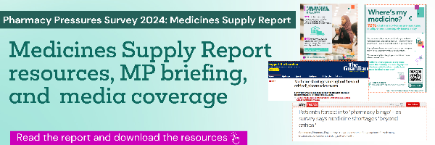

We have received significant media interest in our Pharmacy Pressures Survey 2024: Medicines Supply Report from both national and regional outlets. Prominent news outlets such as ITV News, iNews, The Guardian, Independent, Mirror Sky News, and The Sun have featured our report, bringing attention to the important issues it addresses. Our CEO, Janet Morrison, has also given radio interviews to LBC News and BBC Radio - Essex.
Media coverage and interviews such as these are instrumental in further amplifying our message and raising public awareness about the continuous pressures and challenges faced by our sector. It also supports our work in highlighting these issues – and the growing public concern – to the Government. For support with media interviews, please contact: comms.team@cpe.org.uk
Read our report and view our medicines supply resources



In case you missed it: Since the launch of the Pharmacy First service, Community Pharmacy England has been actively working to provide materials and support to pharmacy owners and their teams. The following resources have recently been added to our library:
- Pharmacy First promotion checklist: Suggested actions to promote the service to their patients.
- Claiming guidance: Help to determine when a consultation can be claimed under the service.
- Pharmacy First materials aimed at GPs: Resources aimed to introduce the service to GPs.



Community Pharmacy England
Address: 14 Hosier Lane, London EC1A 9LQ
Tel: 0203 1220 810 | Email: comms.team@cpe.org.uk
Copyright © 2024 Community Pharmacy England, All rights reserved.
You are receiving this email because you are subscribed to our newsletters. Please note Community Pharmacy England is the operating name of the Pharmaceutical Services Negotiating Committee (PSNC).

