

Newsletter
10th May 2024

This newsletter - sent on Mondays, Wednesdays and Fridays - contains important information and resources to support community pharmacies across England.

In this update: Launch of Funding & Reimbursement Shorts; Support the ongoing case for more funding; Share your views to help improve the NHS App; Medicine supply notices.

Funding & Reimbursement Shorts: Handling prescriptions with supplementary product information
Community Pharmacy England is launching a series of digital guides to help pharmacy owners and their teams understand funding and reimbursement topics. These guides aim to improve practices, maximse income, and reduce instances of lost money or delayed payments.
Presented by some of our in-house Drug Tariff experts, the first video in the series focuses on how to handle prescriptions with supplementary product information, providing practical advice and examples.
Later videos will cover topics such as endorsing Serious Shortage Protocols (SSPs), recent changes to the price concession system, and more. We would also welcome your requests for other future topics – please email ds.team@cpe.org.uk with any suggestions.
Read more and watch the supplementary product information video

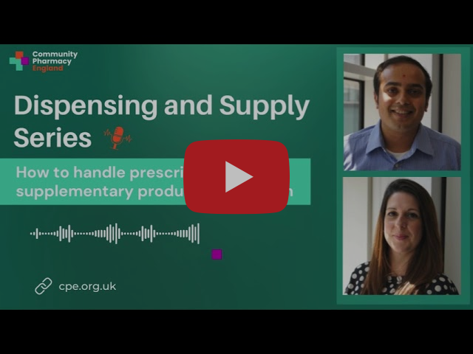



We need pharmacy owners and their teams to help us measure the unfunded care the public receives from you.
By recording information about patients seeking informal advice from your pharmacy, you can help support our case for increased funding for the sector – and capture work not being covered by Pharmacy First. This data will be used both in funding negotiations and in our wider lobbying work with MPs, Ministers, and the national media.
Please take part in the Pharmacy Advice Audit over the course of a single day between 3rd and 16th June. The more pharmacies who get involved, the stronger the data becomes.
Find out how to take part

Quick poll: Pharmacy queries and NHS App improvement
Community Pharmacy England and NHS England's Transformation Directorate are seeking input from pharmacy teams via a quick poll. The survey aims to understand the potential benefits of planned prescriptions functionality in the NHS App.
The survey should take approximately 2-3 minutes of your time. By completing the survey, pharmacy teams can provide insights into patient queries about electronic prescriptions, helping shape future priorities.
Complete the survey

Medicine Supply Notifications
The Department of Health and Social Care (DHSC) has issued medicine supply notifications for the following items (click the hyperlinks below for more information):
- Pancreatic enzyme replacement therapy (PERT)
- Humalog® (insulin lispro) 100units/ml solution for injection 10ml vials
- Lisdexamfetamine (Elvanse®) capsules
- Sulfadiazine silver (Flamazine® ) 1% cream

If you would like to help raise awareness of the worsening medicines supply situation, we have a range of new resources available to support this.
Medicines supply resources for those outside the pharmacy sector



Community Pharmacy England
Address: 14 Hosier Lane, London EC1A 9LQ
Tel: 0203 1220 810 | Email: comms.team@cpe.org.uk
Copyright © 2024 Community Pharmacy England, All rights reserved.
You are receiving this email because you are subscribed to our newsletters. Please note Community Pharmacy England is the operating name of the Pharmaceutical Services Negotiating Committee (PSNC).

