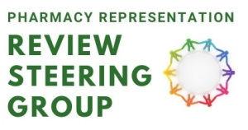

Pharmacy Review Update

Friday 14th January 2022

This update from the Review Steering Group (RSG) contains information on its work to try to improve community pharmacy contractor support and representation.

In this update: Last chance to book on upcoming engagement events; RSG myth-busting and FAQs second edition published.

Reminder: Last chance to sign up for this month’s engagement events
Don’t forget to sign up for one of the three engagement events the RSG will be holding later this month.
During these events, attendees will hear from RSG members and the programme team, who will update them about the group's work, the draft proposals for change, what these mean for contractors and the next stages of the process.
These events are open to everyone with an interest in the sector, and attendees will have the opportunity to ask questions and give feedback. You can register for your preferred event below.
Wednesday 26th Jan 2022 7pm – 8.30pm
Thursday 27th Jan 2022 1pm – 2pm
Friday 28th Jan 2022 11am – 12.30pm

Myth-Busting and FAQs: Second edition published
The RSG continues its myth-busting series with the publication of its second guide, this time focusing on commonly asked questions around the upcoming vote. Further editions will follow so please contact us if there are any areas that you would like to see covered.
Read the RSG Myth-busting and FAQs second edition

Pharmacy Representation Review Steering Group (RSG)
The Pharmacy Representation Review Steering Group (RSG) is taking forward work to improve community pharmacy contractor representation and support.

