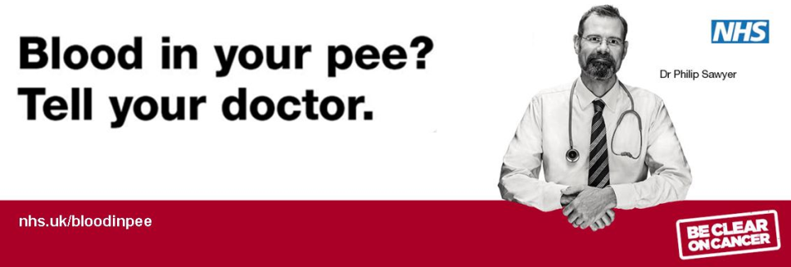

Be Clear on Cancer Blood in Pee Monitoring Sheet

Criteria | Number of interventions | Total
Example |  | 15
Total conversations regarding the
BCOC Blood in Pee campaign?
BCOC Blood in Pee conversations during MUR or NMS consultations?
Customers referred to GP due to BCOC Blood in Pee campaign?

Thank you for your support during this campaign and for making a positive impact on the health and wellbeing of your local population. We will be producing evaluations for each campaign and will ensure you receive regular updates on the impact of the campaigns.

