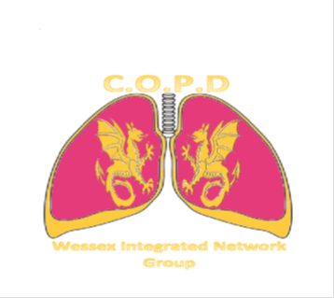
14th December 2017
Chilworth Manor Hotel, Chilworth, Southampton, SO16 7PT
AGENDA
COPD Wessex Integrated Network Group
Date for your Diary!
Professor Tom Wilkinson will be presenting how to understand and prevent exacerbations.
We are delighted to have Professor Mona Bafadhel to talk to us about her work in therapeutic strategies aligned to phenotypes of COPD during exacerbations – who needs antibiotics, who needs oral steroids? The research and practical implications of treatment.
Molly Bennett will be talking about her experiences of exacerbations.
There will be round-table discussions around pathways of treatment.
See you there!
The afternoon will start at 5.30 with a coffee and networking opportunity. Talks will begin at 6pm.
The meeting is sponsored by Pfizer Ltd, TEVA UK, Glaxo Smith Kline, Astra Zeneca, Boehringer Ingelheim and Novartis.
They have a promotional stand at the event and have no influence on the lectures or agenda of the meeting.

Please email helen.kruk@uhs.nhs.uk to book your place!

