Classification: Official
Publication reference: PCS Tier 1

To: NHS Pharmacy Contraception Service Pilot Leads, Pharmacy Commissioning teams  cc. Anne Joshua, Head of Pharmacy Integration | NHS England  Quarry House  Quarry Hill  Leeds  LS2 7UE  20 March 2023

Dear Pilot team Leads.
Extension of the NHS Pharmacy Contraception Service Pilot: Tier 1 – Ongoing Supply of Oral Contraception.
Thank you to all community pharmacies and their teams for their participation in the NHS Community Pharmacy Contraception Service Pilot (Tier 1). Your ongoing support and involvement in the pilot are much appreciated.
I am writing to inform you that it has been decided to extend Tier 1 of the Pharmacy Contraception Service pilot until 30 June 2023, or until the commencement of the Tier 1 Pharmacy Contraception Advanced Service to replace this pilot, whichever is sooner.
All other existing arrangements for participating in the pilot will remain in place during the pilot’s extended period.
It is not our intention to reissue formal documents with the revised pilot extension date. This letter, therefore, acts as formal notification of the date change and should sit alongside the previously circulated documents.
I would be grateful if you would inform the participating pilot sites and community pharmacies in your areas, of this decision. It will be assumed that all pharmacies that signed up to the original SLA will continue their participation in the pilot unless they give notice as set out in the documentation.

Yours sincerely,
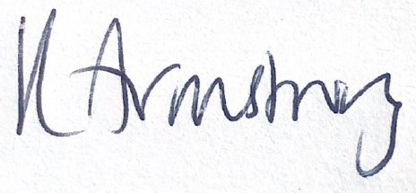
Kirsty Armstrong
Pharmacy Contraception Service Pilot Lead
Pharmacy Integration Lead
Pharmacy Integration, Primary Care Strategy and NHS Contracts
Primary Care, Community Services & Strategy Directorate
NHS England

