Dear Pharmacy Team
Introduction of Foil
We are introducing the provision of foil across the Hampshire Level 2 and 3 Needle Exchange sites.
As part of this we need to ensure that everyone has been trained to talk to clients about the use of foil. A training document is enclosed. The order form will be updated to enable you to order foil. The order form will be sent out via PharmOutcomes along with the updated needle exchange menu. Please do not order any foil until you have confirmed the training has been completed.
Part of the reason for this training is to ensure you are providing clients with harm minimisation information. You were provided with a new leaflet in November 2015, to help with this. If you have run out of these leaflets please let me know. The leaflet can be seen below.
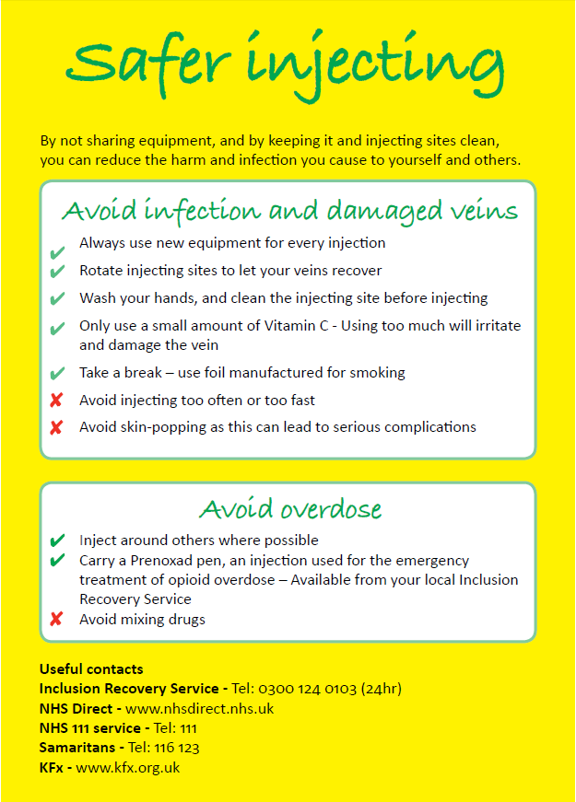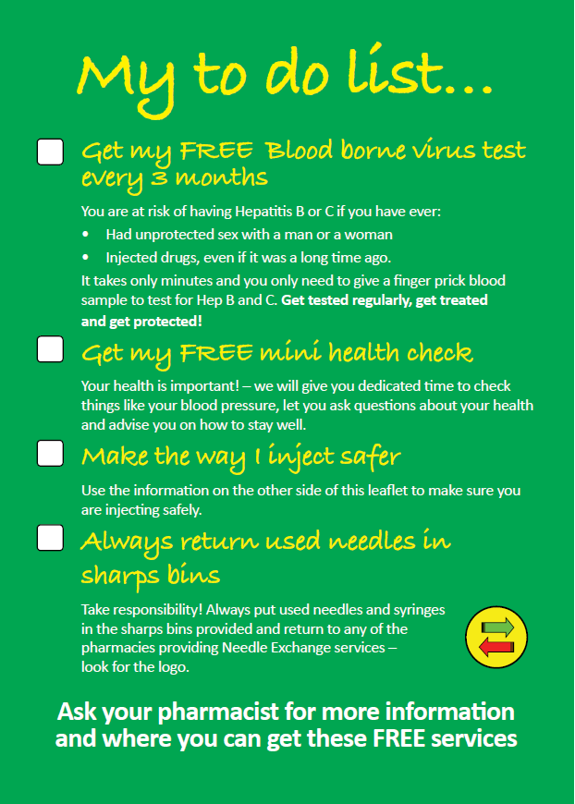
Please complete the below declaration to confirm everyone involved with the needle exchange service has read the training document and is competent to provide advice. Please fax back to 02476 578933.
If you have any questions please don’t hesitate to contact me.
Kind Regards
Stephanie

Stephanie Harris
Commissioned Services Local Manager
Mobile: +44(0) 7702 277671

Confirmation of Foil Training
Pharmacy Name:
Pharmacy Address:
Name of person confirming training completed:
Position of person confirming training completed:
Require Harm Minimisation leaflets (include quantity):

