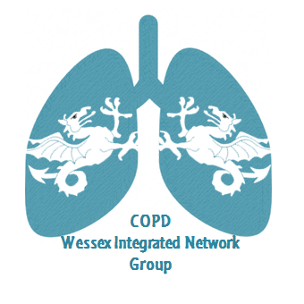
Wessex Integrated Network Meeting
27th March 2019
17.00 – 17.45 Steering group meeting – all and anyone welcome!
17.30 Refreshments, food and networking
18.30 Introduction to the evening by the Chair
Dr Alex Hicks, Consultant Respiratory Physician, QAH, Portsmouth.
18.35 BLF Early COPD cohort study
Bethany Armstead, Respiratory Research Sister, NIHR BRC, UHS, Southampton.
18.40 Clinical Implications of the HOT-HMV Trial: Translating Clinical Trials into Clinical Practice
Professor Nick Hart, Professor of Respiratory & Critical Care Medicine, Clinical Director Lane Fox Respiratory Service, St Thomas' Hospital, London.
19.10 The practical implications of delivering a local NIV service.
Dr Kayode Adeniji, Consultant Critical Care, and Matt Quint, Specialist physiotherapist, QAH, Portsmouth.
19.30 Round table discussions (with coffee)
20.15 Feedback
All
20.45 Close
To book your place, please email helen.kruk@uhs.nhs.uk

